CHAPTER-1
INTRODUCTION
1.1.Problem Statement
Hospitals struggle with ICU overcrowding, staff overload, and inefficient resource use due to limited prediction of patient outcomes. Without accurate forecasts, it is hard to identify urgent cases, estimate length of stay, or allocate resources effectively—leading to higher healthcare and insurance costs.
Our project addresses this by developing an AI-driven patient outcome prediction system. Using vitals, lab results, demographics, and medical history, it builds patient similarity graphs to predict risks like mortality, complications, and hospital stay.
This enables better bed and staff management, supports faster clinical decisions, provides early warnings for deteriorating patients, and reduces costs, ensuring improved patient care and efficient hospital operations.
1.2.Objective
The objective of this project is to develop an AI-driven patient outcome prediction system that analyzes clinical data (vitals, lab results, demographics, and medical history) to predict key outcomes such as mortality risk, length of hospital stay, and likelihood of complications. The system aims to:
- Support doctors with early warnings about patient deterioration.
- Improve treatment decisions by learning from similar past cases.
- Optimize hospital resource management (beds, staff, equipment).
- Enhance patient care through timely and accurate predictions.
- Reduce healthcare costs by preventing avoidable complications.
1.3.Scope of the Project
The project focuses on developing an AI-driven patient outcome prediction system for ICU and hospital settings. It uses patient data such as vitals, lab results, demographics, and medical history to build patient similarity graphs.
The system will predict outcomes such as:
- Mortality risk
- Length of Stay
- Likehood of complications
The predictions will be used to:
- Support doctors in making faster and more accurate decisions
- Provide early warning alerts for patients at risk
- Improve hospital resource planning (beds, staff allocation, equipment use)
- Reduce healthcare and insurance costs by preventing avoidable complications
The project is limited to prediction and decision support; it does not replace doctors or provide direct treatment recommendations.
1.4.Business Cases
1.Hospital efficiency :
- Better ICU bed and staff allocation reduces overcrowding.
- Optimized resource use increases the number of patients treated.
2.Cost Reduction :
- Preventing avoidable complications lowers treatment expenses.
- Shorter hospital stays reduce healthcare and insurance costs.
3.Improved Patient care :
- Early warnings allow timely interventions, reducing mortality rates.
- Doctors can make quicker, data-driven treatment decisions.
4. Insurance Optimization :
- Accurate outcome predictions help insurers estimate costs better.
- Reduces unnecessary claims and improves patient coverage planning.
5. Scalability and Future Expansion :
- The same system can later be extended to predict outcomes for surgeries, chronic diseases, or emergency care.

CHAPTER-2
LITERATURE SURVEY
To design an AI-based system for predicting ICU patient outcomes, it is essential to review existing research in healthcare analytics, deep learning, and medical data modeling. This section provides an overview of related studies, highlighting key methods, technologies, and applications that have contributed to the development of intelligent healthcare systems. Understanding these prior works helps identify existing gaps and supports the rationale behind the approach adopted in this project.
2.1.Existing Methodologies
Existing studies on ICU patient outcome prediction mainly use deep learning models that focus on analyzing patient vitals and clinical records. Most approaches rely on time-series data, such as heart rate, blood pressure, and oxygen levels, to identify health patterns over time. These models aim to detect early warning signs of deterioration and help doctors make timely decisions. However, handling large and complex ICU datasets remains a challenge due to missing values, irregular sampling, and variations between patients.
Models like Long Short-Term Memory (LSTM) networks are widely used because they handle time-dependent data effectively and can capture how a patient’s condition changes. LSTMs can model long-term dependencies in patient data, making them suitable for continuous monitoring and trend prediction. Despite their success, these models usually treat each patient separately and fail to include relationships between patients, which could provide additional context for better outcome prediction.
To address this, some recent works have used Graph Neural Networks (GNNs) to understand connections between patients, such as shared diagnoses, similar lab results, or medical histories. GNNs learn from these relationships to improve prediction accuracy, especially for patients with rare or incomplete data. While these methods show better performance, most still focus on one type of data either temporal or relational which leaves a gap for hybrid LSTM-GNN approach that combine both for a more complete understanding of patient outcomes.

2.2.Technologies used in existing methodologies
- MATLAB: Early studies used MATLAB for preprocessing physiological signals and performing basic statistical analysis on ICU vital signs such as ECG, blood pressure, and oxygen saturation.
- Python & Scikit-learn: Commonly used for implementing classical machine learning models such as Logistic Regression, Random Forest, and Support Vector Machines (SVM) for mortality and length-of-stay prediction.
- Deep Learning Frameworks (TensorFlow & PyTorch): Widely adopted for building models like CNNs, RNNs, and LSTMs that learn directly from multivariate ICU time-series data to predict outcomes such as patient deterioration or mortality.
- LSTM (Long Short-Term Memory Networks): Extensively used for temporal modeling of patient vitals to capture long-term dependencies and detect early signs of deterioration.
- GRU (Gated Recurrent Units): Used as a lightweight alternative to LSTM for faster training while maintaining good performance in time-dependent ICU data prediction tasks.
- Attention Mechanisms: Integrated into RNN/LSTM architectures to focus on the most critical time steps or vital parameters influencing patient outcomes.
- Transfer Learning: Used to adapt pre-trained healthcare or physiological models to specific ICU datasets (like eICU or MIMIC) for improved generalization with limited labeled data.

2.3.How Our Project Overcomes the Existing Limitations

Existing  Limitation | How our project  overcomes that
 | GNN component captures relationships between patients (shared diagnoses, lab results, or treatments), improving prediction through relational learning
  1. Traditional models treat each patient independently, ignoring relationships among patients.
2. Time-series models like LSTM focus only on temporal data.
  Hybrid LSTM + GNN integrates both temporal (time-based) and relational (inter-patient) information for a complete understanding of patient conditions.
3. Handling missing or irregular ICU data remains difficult. | GNN leverages connected patient information to fill data gaps, making predictions robust even with incomplete records.
4. Classical ML models rely on handcrafted features. | Deep learning (LSTM + GNN) automatically learns complex features directly from raw ICU data, reducing manual feature engineering.
5. Limited interpretability of deep models in clinical use. | Attention and feature importance analysis can highlight which vitals or patient links influenced the outcome, improving transparency.
6. Most models focus on a single data type (temporal or relational). | The hybrid model combines both data types, offering richer context for accurate outcome prediction.

CHAPTER-3
Proposed Work and Architecture, Software Requirements Specification, Technology Stack & Implementation Details
3.1.Proposed Work and Architecture
The proposed work aims to develop a hybrid deep learning model that combines the strengths of Long Short-Term Memory (LSTM) and Graph Neural Networks (GNN) to predict ICU patient outcomes more accurately. The system is designed to make use of both temporal data (such as vitals and lab measurements) and relational data (such as shared diagnoses or treatment similarities) to build a more complete representation of each patient.
The LSTM component processes time-series data, capturing how vital signs and physiological parameters change during a patient’s ICU stay. This helps the model learn patterns that indicate improvement or deterioration over time. It focuses on temporal trends that are often early indicators of outcomes like in-hospital mortality or extended length of stay.
The GNN component is used to model relationships between patients. Each patient is represented as a node in a graph, and edges are created based on similarities such as diagnoses, procedures, or comorbidities. The GNN learns how information from similar patients can be shared, improving predictions for patients with rare conditions or missing data.
Finally, the outputs from both networks are combined to produce a final prediction that captures both individual patient progression and inter-patient relationships. This hybrid approach helps overcome the limitations of existing models by integrating temporal and relational knowledge, leading to more accurate, robust, and interpretable predictions. The overall goal of this system is to support clinicians in making timely and informed decisions that can improve patient care and outcomes in critical care settings.
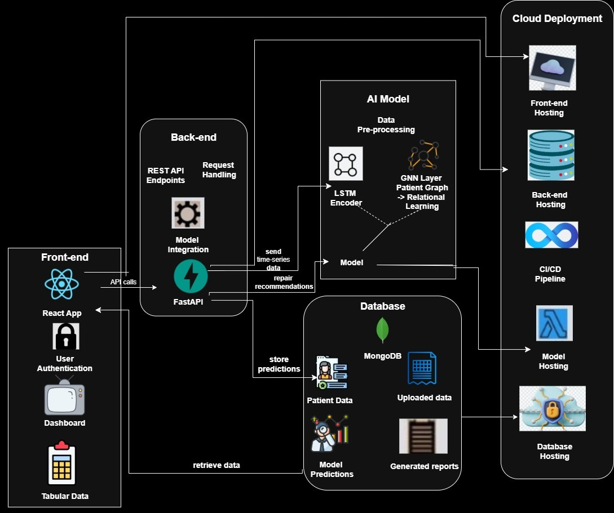

Front-end Layer
The front-end of the system is developed using React.js and serves as the main interface for users such as clinicians and healthcare staff. It provides a secure and interactive environment for accessing patient data and viewing model predictions. The interface includes a user authentication module to ensure that only authorized personnel can access sensitive medical information. Once logged in, users can navigate to the dashboard, where patient vital signs, predicted outcomes, and clinical insights are displayed in a visually organized manner. The front-end communicates with the back-end through API calls to send patient data for prediction, retrieve results, and access generated reports, ensuring smooth and real-time data exchange between the user interface and the system’s core logic.

Back-end Layer
The back-end is built using FastAPI, a modern web framework that ensures high performance and efficient communication between the front-end, AI model, and database. It acts as the central connector of the system, managing all data transactions and request handling. The back-end defines REST API endpoints through which the front-end sends and receives information. When the front-end submits patient data, the back-end validates and processes it before forwarding it to the AI model for prediction. Once the model returns the results, the back-end stores them in the database and makes them accessible for retrieval when required. It also manages model integration, handling the flow of time-series data and returning repair recommendations or predictions to the user. Overall, the back-end ensures a seamless interaction between all system layers while maintaining security and scalability.
AI Model Layer
The AI model layer is the intelligence core of the system, responsible for processing ICU patient data and generating outcome predictions. It consists of a data pre-processing unit, an LSTM encoder, and a GNN layer. The data pre-processing module cleans, normalizes, and transforms the raw time-series data into a suitable format for model input. The LSTM encoder captures temporal dependencies in patient vitals, such as changes in heart rate, oxygen levels, and blood pressure over time. This enables the model to understand how a patient’s condition evolves. The Graph Neural Network (GNN) layer then constructs a relational graph of patients, connecting those with similar conditions or physiological patterns to enable relational learning. By combining the sequential learning capability of LSTM with the relational reasoning power of GNN, the model can make more accurate and context-aware predictions about patient outcomes.
Database Layer
The database layer uses MongoDB, a NoSQL database that efficiently handles large volumes of structured and unstructured medical data. It serves as the system’s storage backbone, maintaining all essential information related to patients, predictions, and reports. Patient data, including clinical histories, vitals, and lab records, are stored securely and can be easily retrieved when required. The model’s predictions and the corresponding generated reports are also saved here for future analysis and reference. MongoDB’s document-oriented structure allows flexibility in handling dynamic healthcare data and supports fast query execution for real-time applications. This database layer ensures that data remains persistent, consistent, and readily available for both clinicians and the AI model.

Cloud Deployment Layer
The cloud deployment layer is responsible for hosting and managing all components of the system to ensure scalability, reliability, and continuous operation. The front-end is deployed on a cloud platform for easy accessibility through a web interface, while the back-end is hosted to handle API requests and process predictions. The AI model is also hosted in the cloud, allowing it to perform computations efficiently without local resource constraints. MongoDB is deployed as a managed database service for secure and reliable data storage. A CI/CD pipeline is integrated into the architecture to automate the process of testing, updating, and deploying new versions of the system. This cloud-based approach ensures that all services remain seamlessly connected, easily maintainable, and accessible to authorized users across different locations.
3.2.SOFTWARE REQUIREMENT SPECIFICATIONS
I. Software Requirements
Operating System: Windows 10 or higher
Programming Language: Python ,JavaScript (React.js) HTML & CSS ,JSON
Libraries & Frameworks:
- PyTorch
- PyTorch Geometric
- NumPy
- Pandas
- Scikit-learn
- FastAPI
- React.js
- Bootstrap
- Tailwind CSS
- MongoDB
II. Hardware Requirements
Recommended:
Processor (CPU) | : Intel Core or higher

RAM | : Minimum 8 GB

GPU | : NVIDIA GPU with CUDA support

Storage | : Minimum 256 GB SSD

Functional Requirements
- User authentication and secure login.
- Upload and management of patient data.
- Time-series data processing and prediction generation.
- Display of prediction results and risk scores on the dashboard.
- Automatic storage of predictions and reports in the database.
- Retrieval of past data and reports for review.
Non-Functional Requirements
- Performance: Real-time processing and quick response to user requests.
- Scalability: Capable of handling multiple users and large datasets simultaneously.
- Security: Data encryption, user authentication, and secure API communication.
- Reliability: Continuous availability with minimal downtime.
- Usability: Simple and intuitive user interface for healthcare professionals.

